**Incremental Refresh**

**Info source :** <https://learn.microsoft.com/en-us/power-bi/connect-data/incremental-refresh-configure>

Incremental refresh extends scheduled refresh operations by providing automated partition creation and management for dataset tables that frequently load new and updated data.

With incremental refresh and real-time data:

****Refreshes are faster****

****Resource consumption is reduced****

****Large datasets are enabled****

* When you configure incremental refresh in Power BI Desktop, parameters are used to filter that's loaded into the model.
* When report published to the Power BI service, with the first refresh operation the service creates incremental refresh and historical partitions
* The service then overrides the parameter values to filter and query data for each partition based on date/time values for each row.
* With each subsequent refresh, the query filters return only those rows within the refresh period dynamically defined by the parameters.
* Rows with a date/time no longer within the refresh period then become part of the historical period, which isn't refreshed.
* When a historical partition is no longer in the historical period defined by the policy, it's removed from the dataset entirely.

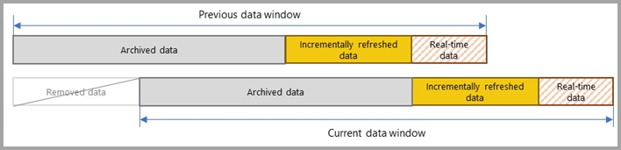

# **Configure incremental refresh and real-time data**

### **Create parameters**

first create two Power Query date/time parameters with the reserved, case-sensitive names RangeStart and RangeEnd.

RangeStart represents the oldest, or earliest date/time

RangeEnd represents the newest, or latest date/time.

### **Filter data**

### **Define policy**